**Digital Signal Processing**

**Experiment 10 – Output**

**Analog Butterworth Filter**

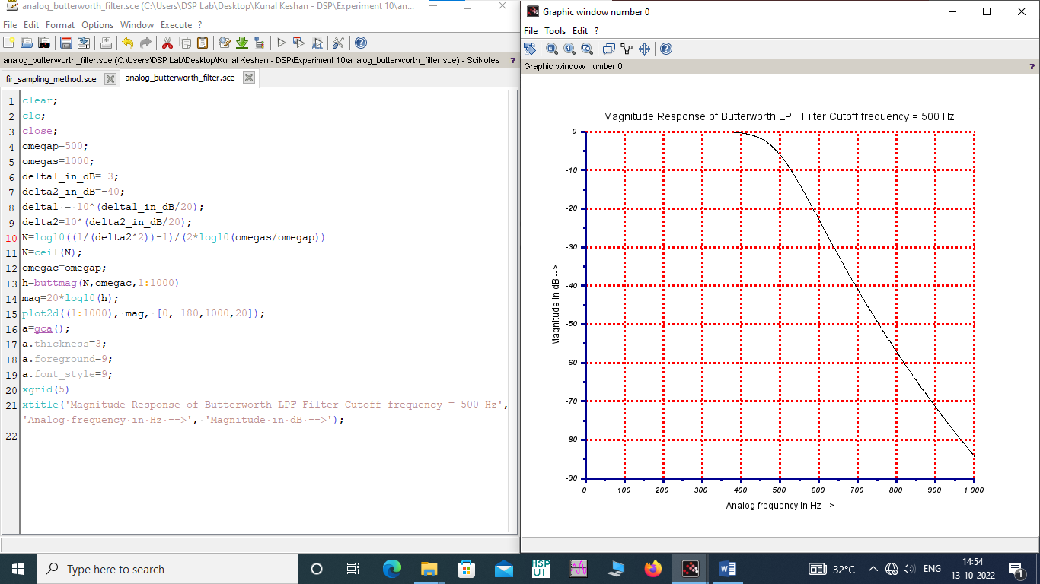

**Chebyshev Filter**

